Schools Analysis

This report is about data from 15 schools in the region. The math and reading scores from the 39,170 students who attend these schools have been used in order to compare outcomes of each school. The total budget of all the schools in the region is $24,649,428.00.

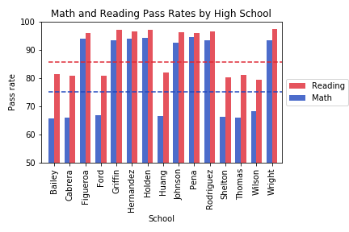

This figure shows a breakdown of the math and reading pass rate by school and the average pass rates across the region. For all schools the reading pass rate is higher than the math pass rate.

Per pupil spending in the region ranges between $578.00 and $652.00 however the data shows that on average the school that have a lower spending achieve higher scores. The average pass rate for schools that spend less than $585 is 95.4% however the average pass rate for schools spending between $645 to $675 is only 73.6%.

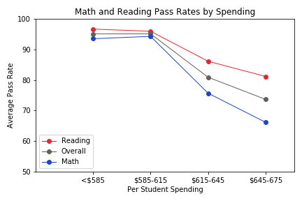

The data shows that the smaller and medium sized schools, up to 2000 students, have higher pass rates than the larger schools. For schools that have fewer than 1000 students the average pass rate is 94.8%. For schools that have between 2000 and 5000 students the average pass rate is only 76.4%.

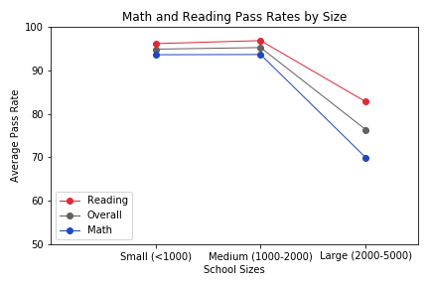

Charter schools in the region have higher pass rates but it is interesting to note that the Charter schools appear to be in general the smaller schools. The average Charter school has 1524 students compared to the District schools that have on average 3854 students. The size of the school may have more of an impact on the results than the type of school.

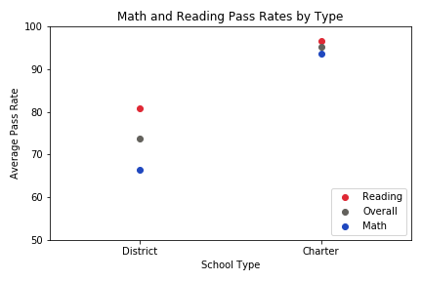

Cabrera High School has achieved the highest pass rate in the region. Cabrera High School achieved an overall pass rate of 95.6%. It is worth noting that it is a charter school with 1858 students and the per student budget is $582.